DEDAK OPERATIONAL REGULATIONS

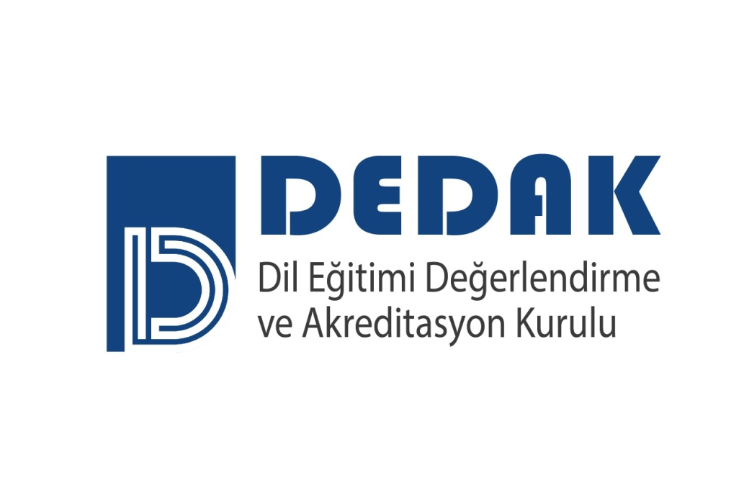
DEDAK - Association for Language Education, Evaluation and Accreditation

E-mail: info@dedak.org
Website: http://www.dedak.org
Phone: +90 212 311 6332

DEDAK OPERATIONAL REGULATIONS

Grounds, Purpose and Scope 3
Definitions and Abbreviations 3
Objectives Pursued in the Accreditation of Language Education Programs 3
Language Education Programs Accreditation Board 4
Program Evaluation Teams 7
Program Evaluators 7
Observers 7
Nominating Committee (ABK) 8
Training for DEDAK 8
DEDAK Evaluation Criteria 9
Conflict and/or Overlapping of Interests 9
Confidentiality 9
Appeals 9
Quality Assurance 10
Archiving of DEDAK Documents 10
Amandements to the Regulations 10
Enforcement 11
Execution 11

DEDAK OPERATIONAL REGULATIONS
Grounds, Purpose and Scope
ARTICLE 1- (1) This regulation has been prepared on the basis of the Charter of the Association for Language Education, Evaluation and Accreditation (DEDAK) Paragraph (g) of Sub-clause (1) of Article (12) “Preparing regulation regarding he operational principles of the Association’s bodies and submitting it to the General Assembly for the approval”.
(2) The purpose of these regulations is to coordinate the operations of DEDAK, the Language Education Programs Accreditation Board (DAK) ,as well as all the other boards, committees and working groups serving as DEDAK bodies.
(3) These regulations cover matters for which a resolution of the General Assembly is needed in regard to the operations of DEDAK.
Definitions and Abbreviations
ARTICLE 2- (1) In the regulations, the following terms and abbreviations will be used to refer to the following definitions:
- ABK: will refer to the Nominating Committee, constituted to assist in the selection of theVice Chair and the members of DAK.
- DAK: will refer to the Language Education Accreditation Board, which directs activities regarding the evaluation and accreditation of Language Education programs on behalf of DEDAK.
- DEDAK: will refer to the Association for Language Education, Evaluation and Accreditation,
ç) General Assembly: will refer to the General Assembly of DEDAK,
- Criteria: will refer to the DEDAK Evaluation Criteria to be used in the accreditation of Language Education Programs,
- TESOL Turkey: will refer to Teaching English to Speakers of Other Language (TESOL) Turkey
- YDYK: will refer to the Board of the Schools of Foreign Languages
- Executive Board: will refer to the Executive Board of DEDAK

Objectives Pursued in the Accreditation of Language Education Programs
ARTICLE 3 – (1) DEDAK pursues the following specific objectives in performing the function of “program evaluation and accreditation” set out in its charter, regulations, and directives:
- Identifying Language Education Programs that meet minimal evaluation criteria in order to inform the society, students, prospective students, student counselors, student parents, educational institutions, professional societies, prospective employers and public organizations,
- Fostering the advancement and continuous improvement of existing programs in Language Education as well as prompting the development of new programs.
- Promoting the development of Language Education.

Language Education Accreditation Board (DAK)
ARTICLE 4 – (1) The Accrediation Board to be formed for the Language Education Programs pursuant to Article 17 of the Charter of the Association for Language Education, Evaluation and Accreditation (DEDAK), takes the necessary actions for the evaluation and accreditation of Language Education Programs. This board is referred to as “DAK” in all the official documents and correspondence of DEDAK.
(2) Duties, Powers and Responsibilities of DAK are as follows:
- Developing quality criteria for accreditation of Language Education programs,
- Preparing and implementing a detailed schedule for the accreditation of Higher Education Programs that basically involve Language Education and taking decisions regarding their accreditation on behalf of DEDAK, and submitting this decision to the Executive Board in writing.
- Selecting the program evaluation teams, team chairs, program evaluators and all the other members to be appointed to take part in the Program evaluation process,
ç) Coordinating program evaluators’ work,
- Establishing sub-comittees to carry out certain tasks and appointing the persons who will be working in these committees, as needed.
- Proposing the Executive Board amendments to the current accreditation processes and evaluation criteria, as needed.
(3) Number of Members and Terms of Office on DAK are as follows:
- DAK consists of a total of six (6) principal and six (6) substitute members; four (4) principal and four (4) substitute academicians from the field of education; one (1) principal and one (1) substitute YDYK representative, one (1) principal and one (1) substitute TESOL Turkey representative.
- DAK membership period starts at the beginning of January and lasts for two (2) years; members cannot serve for a period longer than three (3) consecutive terms in a row. Pursuant to Article 4.4 of this Regulation, such a restriction is not applicable to the member (chair and the immediate past chair) who is destined to serve as the Chair in his/her 4th term because he/she was the Vice Chair in his 3rd term and the member who is destined to be a principal member his/her 4th term because he/she was the Chair in his 3rd term.
- The terms of office is two (2) years for the current chair, current vice chair and the immediate past chair who has served in the previous term. These terms of office cannot be extended. However, pursuant to Article 4.3.b, the vice chair may serve as the chair, the chair may serve as an immediate past chair and an immediate past former chair may continue to serve as a principal member if he/she is re-elected.
(4) Requirements for DAK Membership are as follows:
- DAK members must be experienced in the the fields of language education and/or quality in education.
- At least one (1) of the DAK members must be experienced in the field of accreditation, either in Turkey or abroad.
- Academic DAK members may be retired academic staff or may be currently working in another job.
ç) A person cannot be an Executive Board member on DEDAK and a member of DAK at the same time.
- A person cannot be a member on the DEDAK Auditing Board and a member on DAK at the same time.
- The person who is to be designated as the Vice-Chair of DAK is chosen from among the members who have served on DAK for at least one (1) year prior to holding this position.
- A Chair whose term expires shall hand over his/her position to the the Vice-Chair and continues to serve on DAK for another term acting as the immediate past chair Chair.
(5) DAK Members are appointed as follows:
- The members and the vice-chair of DAK for an upcoming term shall be appointed by the Executive Board from among the candidates to be nominated by ABK, in accordance with the terms of membership, and submitted to the General Assembly for approval.
- The Executive Board may ask for ABK’s nomination to be amended. If the second nomination by ABK is not considered appropriate either, the Executive Board may make a direct appointment and submit it to the General Assembly for approval.
- The process for the selection of the DAK members is carried out in accordance with the ABK Directives, approved and published by the Executive Board.
ç) The member who was chair in the previous term (the former chair) continues to serve as a DAK member on the current Board.
- The Chair’s and Vice Chair’s terms of Office terminate at the end of their two(2)- year DAK membership term.
(6) DAK Meeting Procedures and Operational Principles are as follows:
- The DAK Chair is responsible for DAK’s operations. In the absence of the Chair, the DAK Vice-Chair shall be in charge on behalf of the Chair,
- DAK holds a minimum of two (2) meetings every year. The call for a DAK meeting accompanied by the agenda shall be provided by the DAK Chair to the DAK members, the representative of the Executive Board and the Chair of the Executive Board, in writing and/or by e-mail no later than two (2) weeks prior to a meeting
- DAK members are required to attend the DAK meetings in person. They may not send representatives. The membership of any member shall be automatically terminated, if s/he fails to attend three successive meetings without an excuse.
ç) DAK meetings are held only in the presence of the absolute majority of their members. The Chair, or in the Chair’s absence the Vice- Chair, presides over the meetings.
- DAK meetings are open to the members of the Executive Board, but these members do not have voting rights; the representative of the Executive Board providing a liaison between the DAK and the Executive Board or another Executive Board member shall attend each DAK meeting, as a non-voting member.
- Decisions regarding proposals on regulations, directives and criteria, as well as accreditation decisions are to be based on a minimum of four (4) votes.
- In cases needing immediate negotiation and decision, other than ordinary DAK meetings and accreditation decisions, virtual meetings can be organized with the aid of communication and voting means such as mail, fax, e-mail and web pages. However, the terms described in Article 4.6 are also applicable for decisions made in this manner.
- In order to provide a liaison between DAK and the Executive Board, the DAK Chair attends Executive Board meetings, as a non-voting member.
- In case of resignations from DAK membership before the expiration of the relevant term, action shall be taken according to the following rules:
- In the event that YDYK and/or TESOL Turkey’s delegate resigns, the relevant substitute member shall become a principal member. The relevant candidate for the vacant substitute membership shall be determined by TESOL Turkey and submitted to DEDAK within thirty (30) days. The relevant candidate for the substitute member on YDYK shall be determined in the first upcoming YDYK meeting.
- In the event that principal members other than YDYK and TESOL Turkey delegates resign, the substitute members shall, in due course, serve as principal members. The Executive Board shall appoint the new substitute members for the vacant positions.
- In the event that the Chair resigns, the Vice Chair shall substitute for the Chair until the end of the calendar year by proxy, and shall serve as the current Chair as of the beginning of the following year.
ç) In the event that the Vice Chair replaces some other member or resigns, a member appointed by the Executive Board shall substitute for the Vice Chair until the end of the calendar year by proxy and shall serve as the current Vice Chair as of the beginning of the following year. These operations shall be conducted in accordance with the procedures defined in Article 4.4.
A member who is replacing another member that has withdrawn from DAK membership for some reason, shall continue to be a member until the term of office of the member he/she is replacing expires.

Program Evaluation Teams
ARTICLE 5 – (1) Program Evaluation Teams are:
- Accreditation evaluations are conducted by program evaluation teams.
- Program evaluation teams are formed by DAK. A separate evaluation team is formed for each institution whose programs are to be evaluated.
- Program evaluation teams consist of a Team Chair, Program Evaluators and a student evaluator. Observers may also be included in the teams, if deemed necessary.
ç) The Team Chairs are appointed from among those members who are currently serving or have previously served on DAK or, if required, from among experienced program evaluators who have previously served as DEDAK Evaluators.
- The rules to be observed in forming the program evaluation teams are determined by the Directive on Policies and Procedures for Evaluation and Accreditation, as approved and published by the Executive Board.

Program Evaluators
ARTICLE 6 – (1) Program evaluators are determined as follows :
- A pool of program evaluators is formed consisting of people who have considerable experience in the field of Language Education.
- Each program evaluator is expected to have completed the training program provided by DEDAK before participating in the visit. Observers may also participate in a visiting team.
- When selecting the persons to be included in the pool of Program evaluators, academic members with profound knowledge and experience in the fields of program development, testing-assessment, training managment and inservice training are considered.
ç) The rules to be observed in forming the pool of program evaluators shall be determined by the Executive Board.

Observers
ARTICLE 7 – (1) If deemed necessary, DEDAK members or evaluator nominees may join the evaluation teams as observers upon DAK’s decision, provided that the approval of the team chairs and the relevant bodies has are obtained.
- Within the scope of the cooperation of DEDAK with foreign accreditation organizations, a representative from one of these organizations can join (at least one of) the program evaluation teams (every year) as an external observer. The organizations to be asked for external observers and the relevant arrangements are (to be) determined by the Executive Board.
- The Executive Board may ask External Observers to submit a feedback report at the end of their evaluation visits. The Executive Board holds the authority and responsibility to evaluate the feedbacks and ensure their use in the improvement process.

Nominating Committee (ABK)
ARTICLE 8- (1) The mission of the Nominating Committee (ABK) is providing assistance in the election of the Vice Chair and the members of DAK. It consists of the following four (4) members:
a) The immediate past Chair of DAK, who will also serve as the Chair of ABK,
b) Chair of DAK,
c) Vice Chair of DAK,
ç) An Executive Board member acting as a liaison between DAK and the Executive Board,
(2) The following rules shall be effective in case of withdrawal from ABK membership before the expiration of the relevant term:
a) There shall be no election in the event that DAK’s immediate past chair who is also supposed to serve as the chair of ABK withdraws from membership. The ABK membership reserved for him/her shall remain vacant until the end of the relevant term. In this case, ABK shall operate with three members and the current DAK chair will also serve as the the Chair of ABK.
b) The procedures to be followed in the event that the Chair of DAK or the Vice Chair of DAK withdraws from membership shall be conducted in accordance with the rules defined in Article 4.8.
- The duties, powers and responsibilities of ABK are determined by the ABK Directive, approved and published by the Executive Board.
Training for DEDAK
ARTICLE 9 – (1) All the new DAK members need some training. They are informed on certain issues, such as DEDAK’s policies, the structure and operations of DAK and the accreditation process.
- All the new members of the Executive Board and the Auditing Board of DEDAK are informed on DEDAK’s policies and operations.
- The candidates included in the pool of program evaluators need to complete the training process successfully. Prospective evaluators who have not served as evaluators for (a period of) three years after receiving program evaluator training are required to undergo evaluator training once again before serving as an evaluator.
- DEDAK may organize briefings and training programs for the staff of institutions intending to apply for accreditation evaluation.
- The Training Committee formed by the Executive Board is responsible for the organization of DEDAK’s training programs. The structure of the training committee, the appointment of its members, the terms of duty, and the operational principles are set out by the Training Committee Directive, approved and published by the Executive Board.

DEDAK Evaluation Criteria
ARTICLE 10 – (1) The criteria used by DEDAK in the evaluation of Language Education programs sets the minimum accreditation requirements to be met by a Language Education program.
- The Criteria Committee is formed by the Executive Board for revising and updating the existing criteria regularly, as well as for carrying out similar studies in this field.
- For any changes to the DEDAK evaluation criteria, the opinions of external stakeholders and that of internal stakeholders shall be sought.
- Changes to the criteria shall be put into effect upon the decision of the Executive Board and become effective as of the next evaluation period, in two years time.
- The structure, election, and term of office of its members, the operational principles of the Criteria Committee, and the procedures to change the criteria are determined by the Directive on the Procedures for Determining Evaluation Criteria that is approved and published by the Executive Board.

Conflict and/or Overlapping of Interests
ARTICLE 11 – (1) The principles and practices regarding conflict and/or overlapping of interests are regulated and executed by the Executive Board in accordance with the principles defined in DEDAK’s Code of Ethics.

Confidentiality
ARTICLE 12 – (1) The information provided by the institutions is strictly for the confidential use of the members of DEDAK’s boards, DEDAK employees and program evaluators and shall not be disclosed without specific written authorization from the institution concerned.
- All documents distributed at the Executive Board and DAK meetings, for the purpose of making evaluations and holding discussions, are deemed as confidential documents, and their contents are confidential information.
- The contents of such documents, as well as any accreditation decisions may only be disclosed by the staff who are in charge and only under specified conditions.
- Members of the DEDAK boards, DEDAK employees and program evaluators shall sign a Confidentiality and Ethics Statement provided in the annex of the DEDAK Code of Ethics, stating that they understand and shall observe these principles of confidentiality.

Appeals
ARTICLE 13-(1) Institutions being evaluated for accreditation may make an appeal in response to DEDAK‘s “not to accredit” decision.
- Such appeals or claims may be based only upon the grounds that the “not to accredit” decision was inappropriate because of errors of fact or failure to conform to the published criteria, policies or directives of DEDAK.
- Evaluation and due decision about appeals shall be subject to the Directive on Policies and Procedures for Evaluation and Accreditation.

Quality Assurance

ARTICLE 14-(1) DEDAK’s operations within the scope of Quality Assurance are as follows:
  - Quality Assurance and Continuous Improvement: DEDAK’s quality policies are defined by DEDAK’s Executive Board. The Executive Board shall issue a Quality Policy document summarizing these quality policies. The executive board carries out all activities with due diligence; reviews work practices, develops and implements programmes to ensure quality assurance and continuous improvement to realize these goals.
  - External Auditing: In addition to internal quality auditing, DEDAK is also evaluated by an external quality organization at least once every five (5) years. The agencies to be employed with such evaluation and the timing of the evaluations shall be decided by the Executive Board, with due consideration of the requirements for DEDAK’s national and international recognition.
  - Transparency and Accountability: DEDAK is responsible for informing all stakeholders and the public about its program evaluation and accreditation activities. Hence, the following information and documents are published on DEDAK’s web page (www.dedak.org):
- DEDAK Evaluation Criteria used for evaluation and accreditation,
- The format of the self-assessment report, which clearly describes the evaluation and accreditation process and the scope thereof for institutions of higher education applying to DEDAK for program evaluation and accreditation, evaluation processes and procedures, and similar documentation
- The Annual Operation Report summarizing DEDAK’s annual operations, including its evaluation and accreditation activities,
- The list of Language Education programs accredited by DEDAK, as well as some details pertaining to the accreditation process, such as the period of the accreditation and the terms of the accreditation granted.

Archiving of DEDAK Documents
ARTICLE 15 – (1) Documents and reports related to DEDAK’s activities are filed and archived regularly. The Chair of the Executive Board ensures that all the official documents and reports in the possession of DEDAK are securely archived and maintained.
(2) DEDAK keeps a record of the list of the programs accredited, the types of the accreditations granted and their period of validity.
(3) The methods and periods for the archiving of the documents and reports regarding DEDAK’s activities, including the documents and reports related to the accreditation process and the results thereof, shall be subject to the Archiving Directive, to be approved and published by the Executive Board.

Amendments to the Regulations
ARTICLE 16 – (1) Proposals for any amendments to these regulations shall be submitted to the General Assembly by the Executive Board. Such proposals should also include a suggested date on which the amendment shall become effective. Proposed amendments to regulations that require any amendments to the Charter shall be submitted to the General Assembly together with the required changes in the Charter.
(2) Proposals issued by the Executive Board for amendments to these regulations shall be included in the meeting agenda and resolved in the first meeting of the General Assembly.

Enforcement
ARTICLE 17 – (1) These regulations are effective as of the date of adoption by the General Assembly.

Execution
ARTICLE 18 - (1) The Chair of the Executive Board executes the provisions of this directive.

TEMPORARY ARTICLE 1 –The initial members of DAK and ABK shall be nominated and appointed by the Executive board. Nominations and related assignments regarding the first boards to be formed shall also be conducted by the Executive Board.

